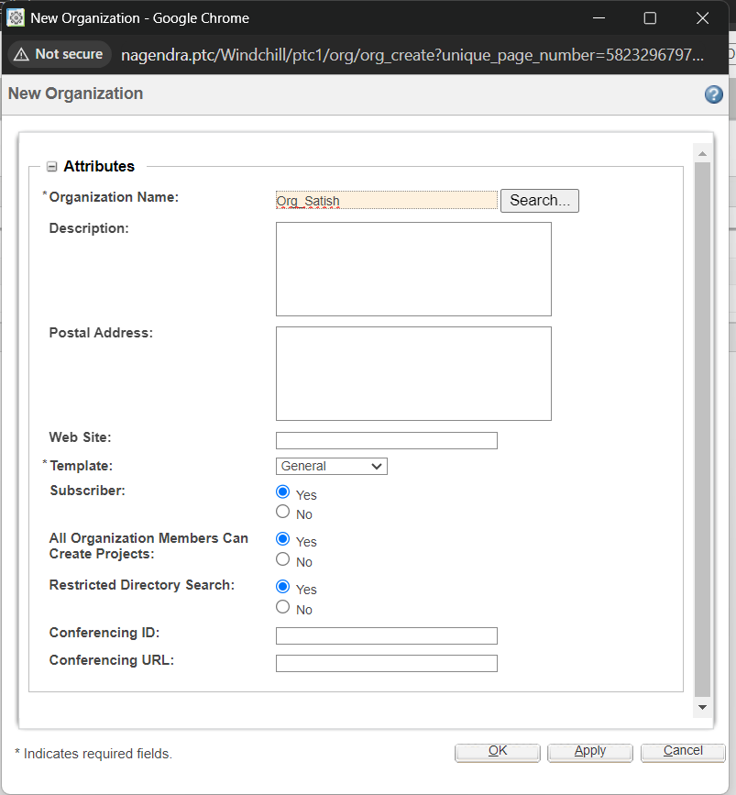

After login as wcadmin, goto Organisations and Create one new Organisation, as named

After Create a User as named shown, in side that organization

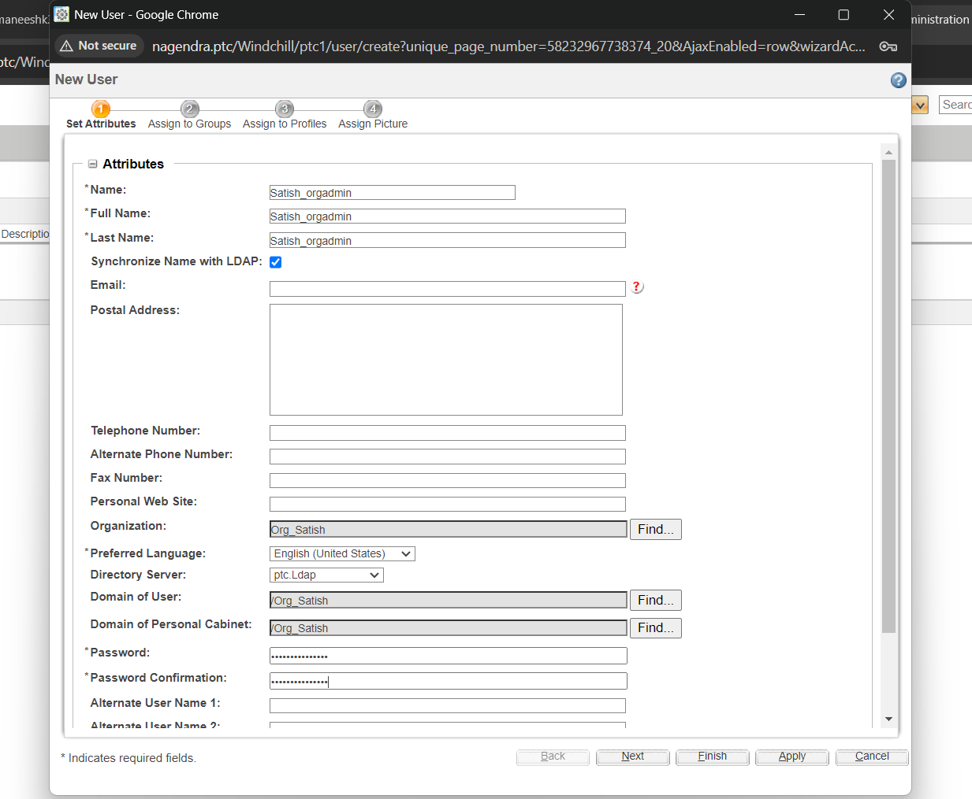

And Make the user Satish as the Admin

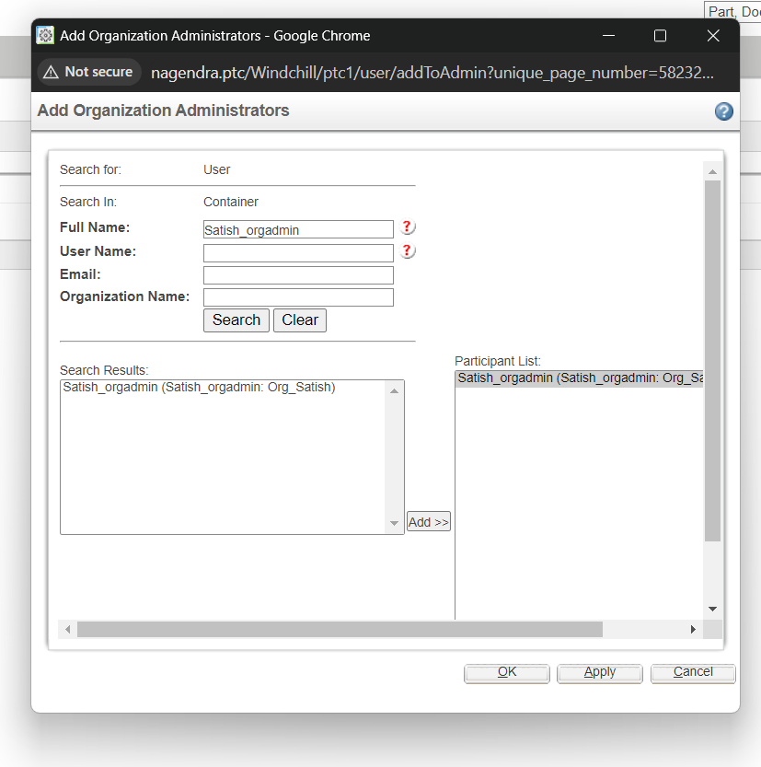

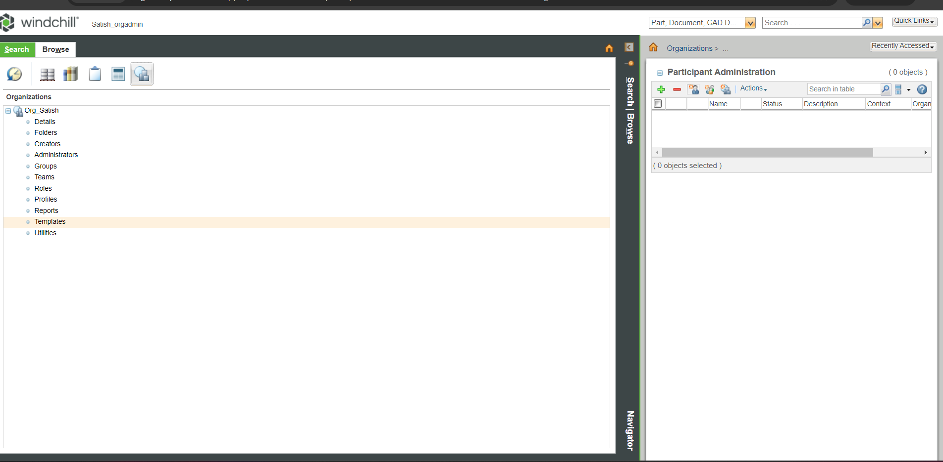

And Login as that Created user and able to Access that Organisation

And Create  product_user001, library_user001, allcreator001…. As shown

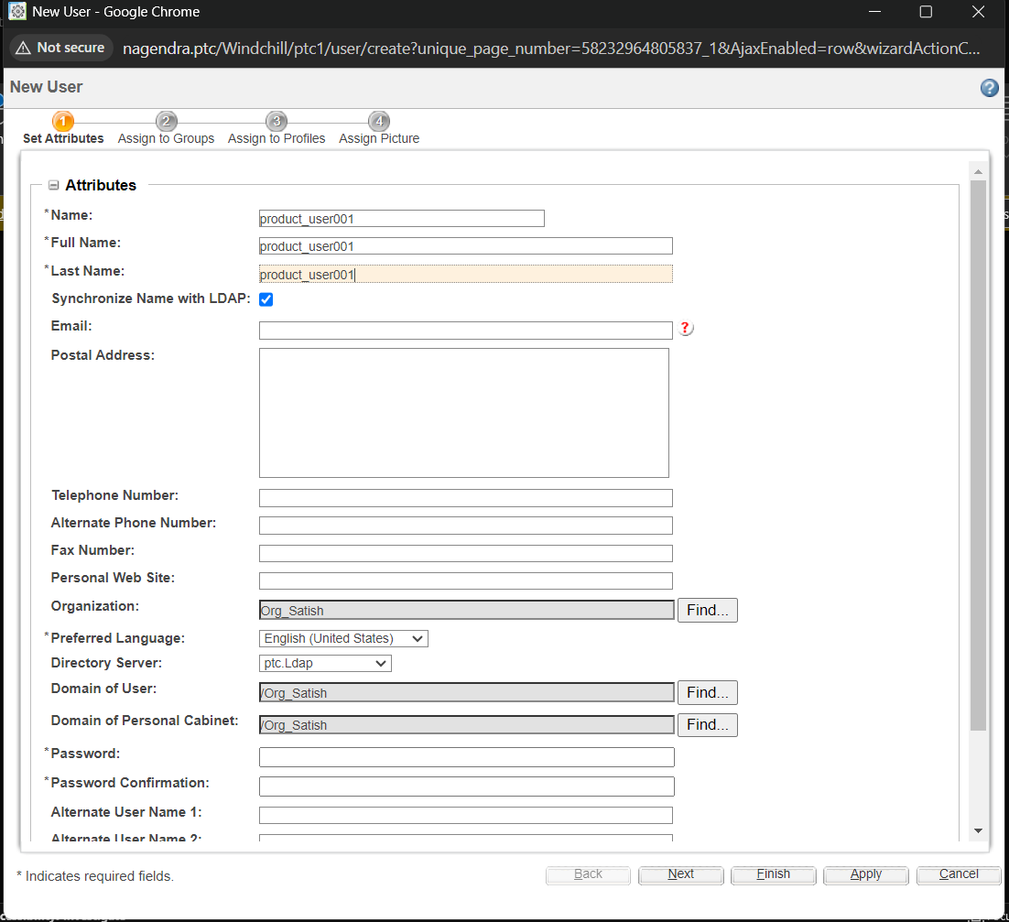

Three users created and shown as below:

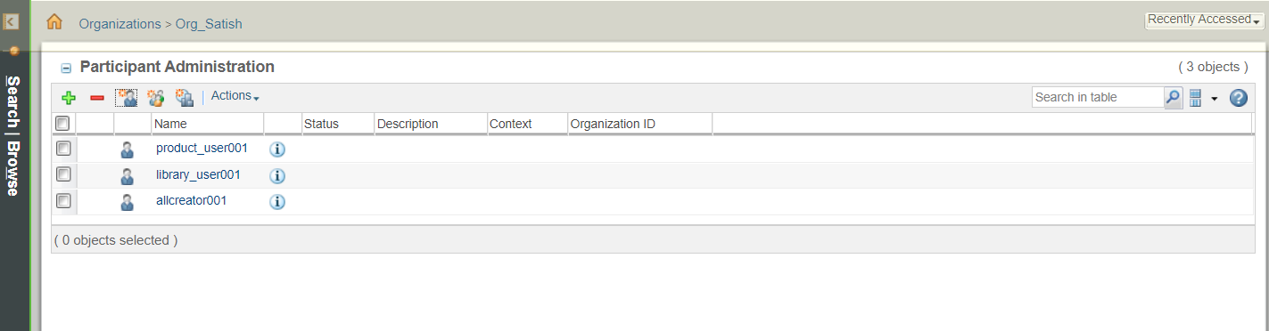

And Make both Creators as Product Creators as shown and Lib_user as library creator.

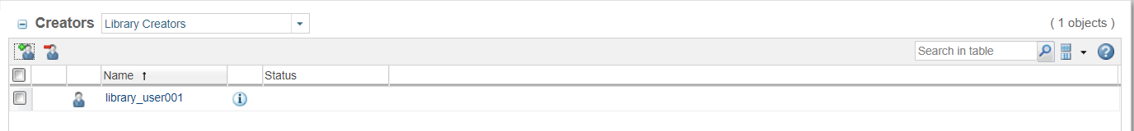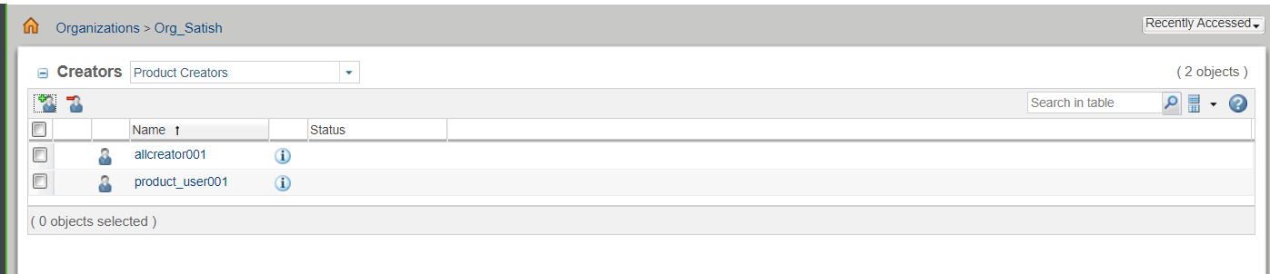

Login with product_user001 and Create a product001 as shown

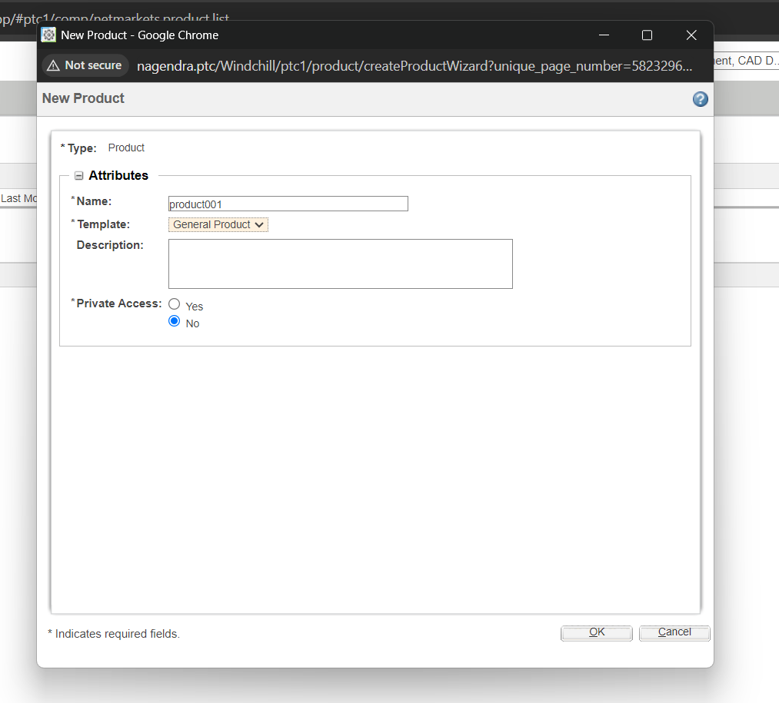

Login with product_user001 and Create a product001 as shown

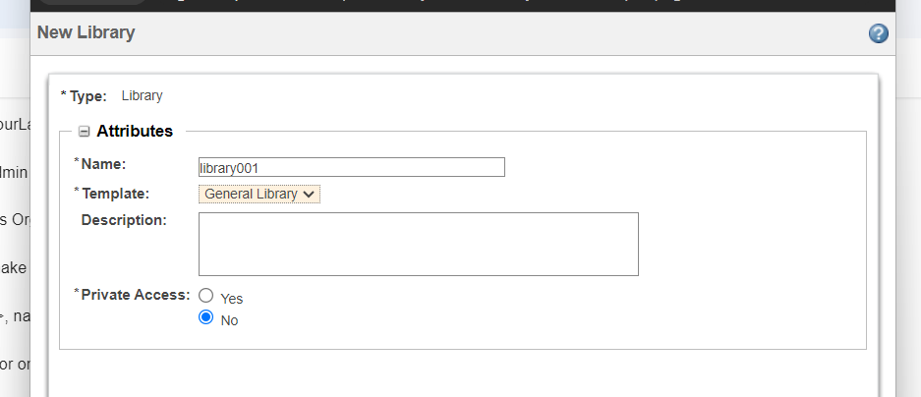

And also login as library_user001 and create a library001.

After that create two more users u001,u002 as shown in Satish_orgadmin

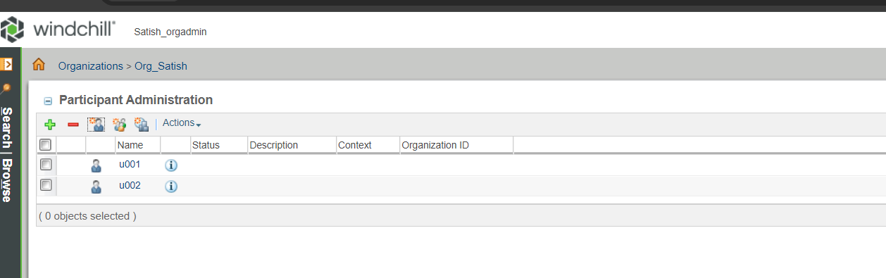

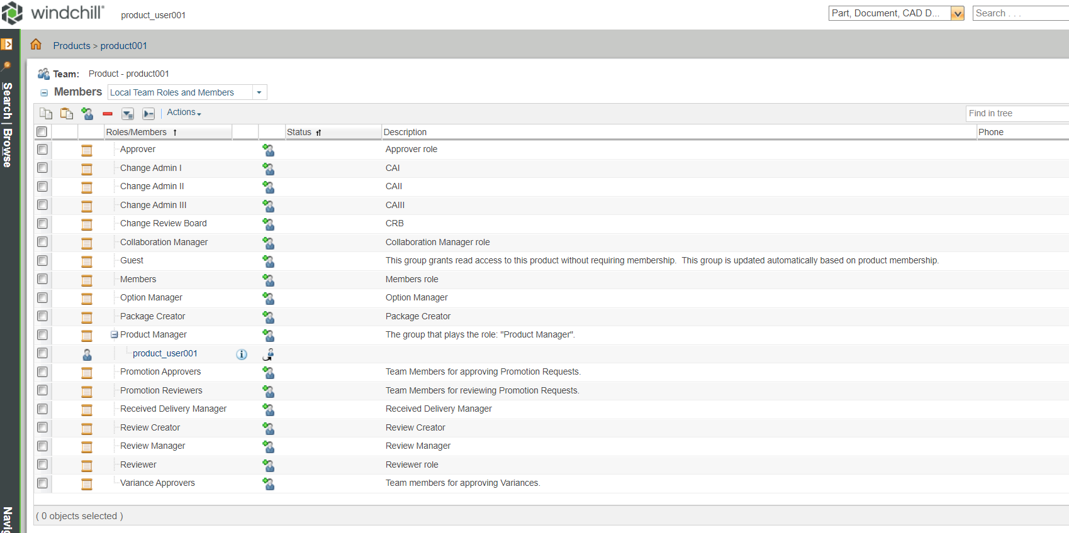

Make u001 as member of product 001 as shown

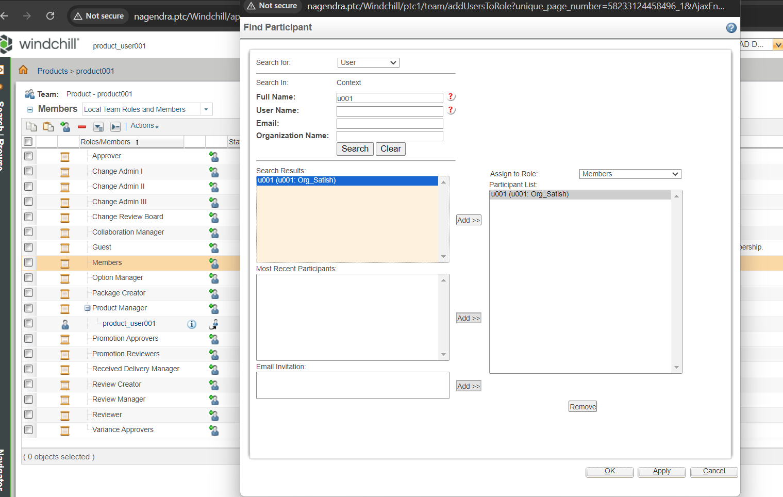

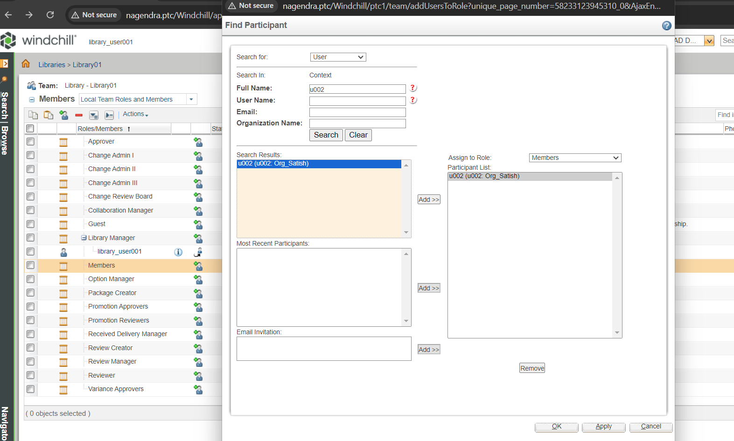

Similarly login as libraryuser001 and make the member u002 part of library01 as shown, login as allcreator and see he can able to create new products,libraries as shown.

